1. **Experiment:** The optimization of sequence
2. **Time:** 2024.10.04-2024.10.05
3. **Member:** Xudong Tang, Qiwen Jiang, Binxuan Zhang, Xuantong Liu
4. **Method:**
5. Notably, although the candidate sequences, specifically B0, B34, and B51, along with G9, G16, G35, G42, G57, and G71, engaged the binding interface via fewer than four amino acids, a substantial portion of their sequences remained uninvolved in IL-2 binding. Consequently, these sequences were truncated to retain only the 20 amino acids implicated in binding interface contacts, with the exception of B34, which was truncated to 39 amino acids for further investigation (Table.1, 2).
6. In PyMOL, based on the pre-existing file, we clicked "Display" → "Sequence", selected the corresponding amino acid residues, and executed "Remove Atoms" to generate the result shown in the figure below (Fig.1).
7. **Result:**

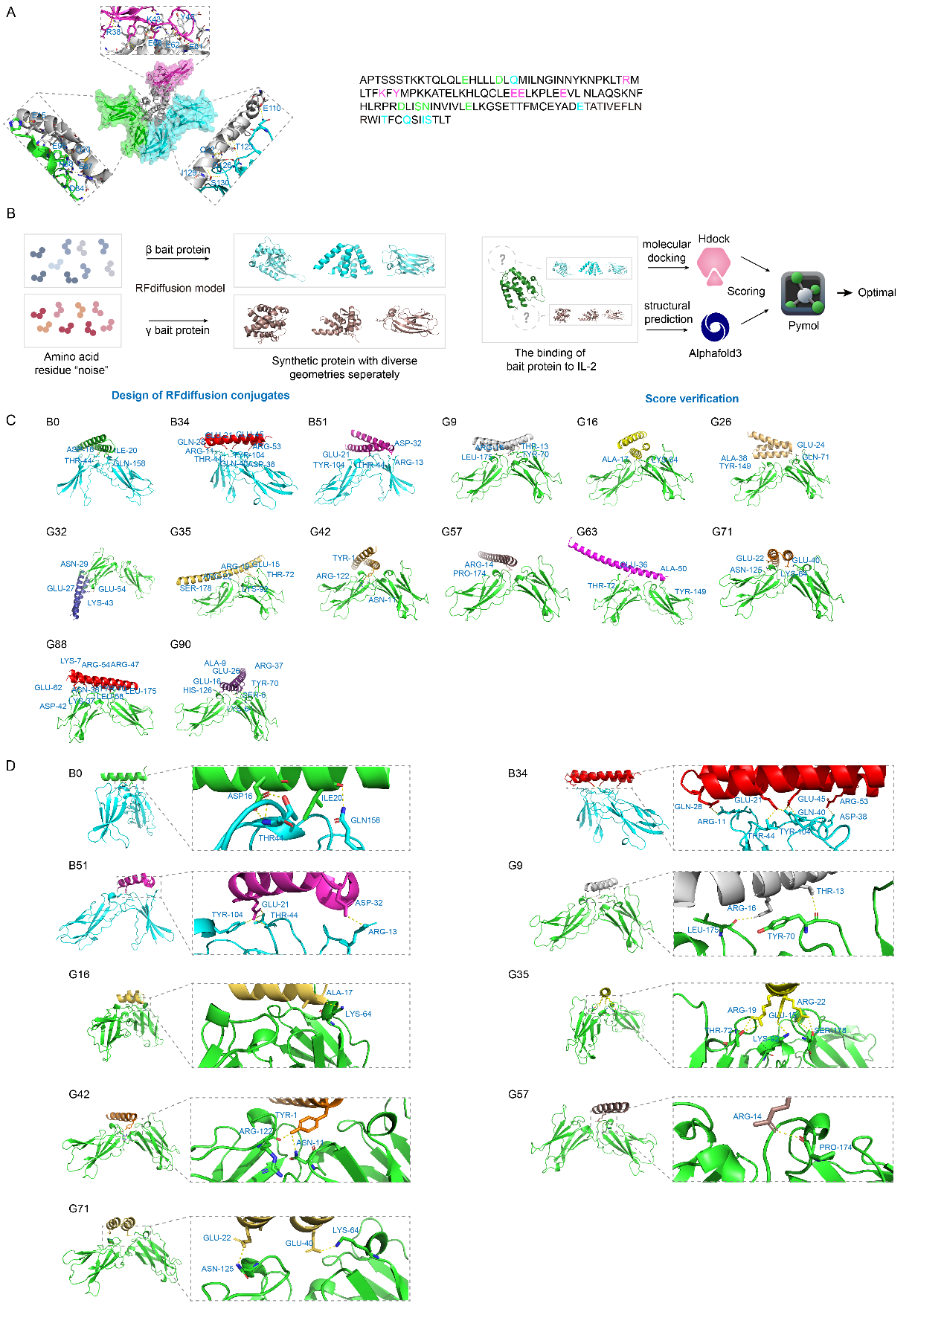

**Fig.1** Binding interfaces between the trimmed sequences and the IL-2Rβ and γ respectively, with the box zooming in to show the amino acids at the binding site (stick representation).

**Table.1** The γ Complex Design Model

|  |  |
| --- | --- |
| **Complex design model** | **Sequence** |
| G9 | SAAAKEAAKALATALRLAGTRLFTAGAVAAKIDPAAGAALFAAGAAAFAAAAALEKALA |
| G16 | MSLAEAIRDAGVAAALASGDPAHLDAAKAAIAAAVSPEEAARWAAVLDEDYARARAAAA |
| G35 | AAEEEAERLRRAAAELAERLARAALLAALRAALAARLAANALKIAAAAAALAAAAA |
| G42 | YLEEAVAALKKLRDDLAAQLAKAKAAADTPEMKALAAETQALLELATKQLEKAEAKLK |
| G57 | EELARLAEELAAARREALRAELEALRREQEERLREEEEERRRREEEEK |
| G71 | DVATLKALAAQYRAARAAVREEAARLAAAEPERAAEILAEGAALAAAFDAKAAAAAAAAAAAA |

**Table.2** The β Complex Design Model

|  |  |
| --- | --- |
| **Complex design model** | **Sequence** |
| B0 | MEEKLEELKKKLAELDGKYIYEKCYGTEEEAKKALEELKAALEELAKAEKEAAAAAA |
| B34 | AAEAARRAARAAFDARLTAAERKYLAAQDDPEAAAAWLAEIAAIEAERTAAERAWAA |
| B51 | EEERRRQIEALKRAAAAAEYEYALAKELAAKDPAYAPLAEALKAELERLKAELAALEAA |